**Fundamentals of Materials Processing (Part–1)**

**Professor Shashank Shekhar**

**Department of Materials Science and Engineering**

**Indian Institute of Technology, Kanpur**

**Lecture Number 11**

**Heat Flow (Interface Resistance controlled Solidification)**

**Keywords:** interface resisatnce, temperature gradient, steady state, electrical analogy, powder production, root time

Okay, so we are back, and we will get started where we left last time, which was discussing what is the implication of the slope whenever we draw this temperature profile.

(Refer Slide Time: 02:58)

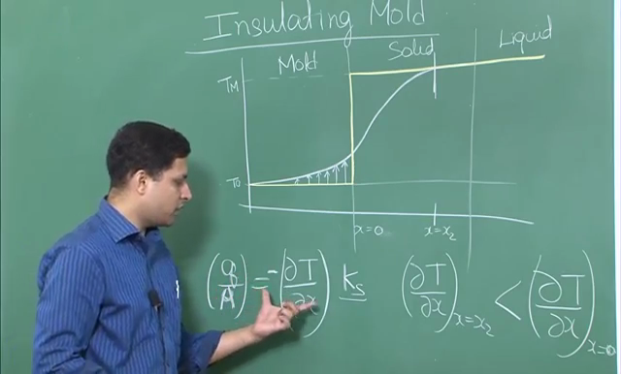

So you remember we talked last time about the rising slope for the mold part, and the decreasing slope when we are going from mold-solid interface towards the solid-liquid interface; there is a decrease in slope for the solid part. So we showed that even you have a increasing slope like this, it means that the amount of heat that goes in from here is higher than the amount of heat that is coming out, and the implication is that that is because the mold is getting heated up. So the some amount of heat is getting absorbed.

Now what about this point? Let us say, we are talking about somewhere over here, which is   
x = x2, and this is our usual x = 0. So let us look at what happens over here. So



Okay, so it is the same thing I have written KS towards the second part, but the equation is same. Now over here, what do you see? , which is the amount of heat going in per unit area, per unit time, into a particular interface. So let us say we are talking about this, comparing this versus this.



Now this is at x = x2, what is different at x2 versus x0, what is different; this is not different, this is the material property, so it is constant. This is different; this is is small over here. So, if you will look at the quantity



This is okay, we have been using this as 0, not x0. This is x = 0. So, what is changing is the slope, and we see that the slope over here is less than the slope over here, which means if we look in terms of , and there was a minus sign, but as far as we are concerned with the magnitude, you would see that the magnitude wise, the heat that is going in is small over here, and the heat that is coming out is larger over here.



So is not that very surprising that, the amount of heat that is going into the solid at this point is less, but the amount of heat that is coming out at this point is higher. So why is that happening? Here we said that the mold is heating up, so can we say anything similar about this part; and yes, we can actually say something similar about this part. So you remember this was your original temperature profile, meaning the solid was all the way up to TM temperature, just a little bit less than TM, after solidification. So what is happening is that, the solid is cooling down a little bit.

So when it is cooling down, amount of energy equal to Cp∂T or Cs∂T will also get added into the heat that has gone in here. So the total amount of heat of this Cp∂T; so the ∂T for each and every point is different, and so you will calculate the Cp∂T for each small incremental amount of the solid, and calculate the total additional energy, so that will be equal to the total energy that is getting transmitted at this point. Now few more things. What can we say about the slopes at this point versus this point? Should they be equal? Well, let us look at it.

One thing we know, if we are just talking about one interface, then the amount of heat coming out should be equal to the amount of heat going in, the resistance of the interface is negligible, that is, if we assume that no loss is taking place because of interface, which is also called as interface resistance, we will see next, then, the amount of heat coming out from this solid-mold interface should be the equal to the amount of heat going into the solid-mold interface towards the mold side; meaning should be equal to . So this is the total amount of heat, both of them should be equal.

